

**VIRGINIA COMMONWEALTH UNIVERSITY**

**Statistical analysis and modelling (SCMA 632)**

**A6b-Part A**

**Bala Vignesh Aravindan**

**V01106579**

**Date of Submission: 25-07-2024**

**CONTENTS**

|  |  |  |
| --- | --- | --- |
| **Sl. No.** | **Title** | **Page No.** |
| **1.** | Introduction | **1** |
| **2** | Results | **2** |
| **3.** | Interpretations | **2** |
| **4.** | Recommendations | **2** |
| **5.** | Codes | **3-7** |

**"Volatility Forecasting of Apple Inc. (AAPL) Stock Returns using ARCH/GARCH Models"**

**Introduction**

Volatility forecasting is a crucial task in finance, as it enables investors and portfolio managers to make informed decisions about risk management and asset allocation. Apple Inc. (AAPL) is one of the largest and most widely followed companies in the world, and its stock price is subject to various market and economic factors that can affect its volatility. In this report, we aim to forecast the volatility of AAPL stock returns using ARCH/GARCH models, which are commonly used in finance to model and predict volatility.

**Objectives**

The objectives of this report are to download and prepare AAPL stock data from Yahoo Finance, check for ARCH/GARCH effects in the data, fit an ARCH/GARCH model to the data, forecast three-month volatility using the fitted model, and visualize and interpret the results.

**Business Significance**

Accurate volatility forecasts can have significant implications for investors and portfolio managers. By anticipating changes in volatility, investors can adjust their portfolios to minimize risk or maximize returns. For example, if volatility is expected to increase, investors may choose to reduce their exposure to the stock or hedge their positions. Conversely, if volatility is expected to decrease, investors may choose to increase their exposure to the stock. Therefore, volatility forecasting is an essential tool for investment decision-making and risk management**.**

**Statistical Results**

The ARCH/GARCH effects test revealed significant evidence of ARCH/GARCH effects in the AAPL stock returns data. The fitted ARCH/GARCH model had a constant mean, a GARCH(1,1) variance, and a Student's t-distribution for the residuals. The parameters of the fitted model were estimated using maximum likelihood estimation. The forecasted volatility values for the next three months were 0.000432, 0.00042, and 0.00041, respectively.

**Interpretation**

The results of the ARCH/GARCH effects test suggest that the AAPL stock returns data exhibit volatility clustering, which means that periods of high volatility are followed by periods of low volatility. The fitted ARCH/GARCH model captures this behavior and provides a good fit to the data. The forecasted volatility values suggest that volatility is expected to decrease slightly over the next three months. This could be due to various factors, such as changes in market sentiment or macroeconomic conditions.

**Conclusion**

In conclusion, this report demonstrates the use of ARCH/GARCH models for volatility forecasting of AAPL stock returns. The results suggest that the fitted model provides a good fit to the data and that volatility is expected to decrease slightly over the next three months. These findings can be useful for investors and portfolio managers who need to make informed decisions about risk management and asset allocation.

**Recommendation**

Based on the results of this report, we recommend that investors and portfolio managers closely monitor the volatility of AAPL stock returns and adjust their portfolios accordingly. If volatility is expected to decrease, investors may choose to increase their exposure to the stock. Conversely, if volatility is expected to increase, investors may choose to reduce their exposure to the stock or hedge their positions.

**Codes**

**Python Code**

**import** yfinance **as** yf

**import** pandas **as** pd

**from** arch **import** arch_model

**Download data from Yahoo Finance**

In [7]:

data **=** yf**.**download('AAPL', start**=**'2010-01-01', end**=**'2024-07-19')

[*********************100%%**********************] 1 of 1 completed

In [8]:

display(data)

|  | **Open** | **High** | **Low** | **Close** | **Adj Close** | **Volume** |
| --- | --- | --- | --- | --- | --- | --- |
| **Date** |  |  |  |  |  |  |
| **2010-01-04** | 7.622500 | 7.660714 | 7.585000 | 7.643214 | 6.461977 | 493729600 |
| **2010-01-05** | 7.664286 | 7.699643 | 7.616071 | 7.656429 | 6.473148 | 601904800 |
| **2010-01-06** | 7.656429 | 7.686786 | 7.526786 | 7.534643 | 6.370183 | 552160000 |
| **2010-01-07** | 7.562500 | 7.571429 | 7.466071 | 7.520714 | 6.358407 | 477131200 |
| **2010-01-08** | 7.510714 | 7.571429 | 7.466429 | 7.570714 | 6.400680 | 447610800 |
| **...** | ... | ... | ... | ... | ... | ... |
| **2024-07-12** | 228.919998 | 232.639999 | 228.679993 | 230.539993 | 230.539993 | 53008200 |
| **2024-07-15** | 236.479996 | 237.229996 | 233.089996 | 234.399994 | 234.399994 | 62631300 |
| **2024-07-16** | 235.000000 | 236.270004 | 232.330002 | 234.820007 | 234.820007 | 43234300 |
| **2024-07-17** | 229.449997 | 231.460007 | 226.639999 | 228.880005 | 228.880005 | 57345900 |
| **2024-07-18** | 230.279999 | 230.440002 | 222.270004 | 224.179993 | 224.179993 | 65964400 |

3659 rows × 6 columns

**Convert data to returns**

In [9]:

returns **=** data['Adj Close']**.**pct_change()

**Check for ARCH/GARCH effects**

In [11]:

returns **=** returns**.**dropna()

In [13]:

returns **=** returns**.**fillna(0)

In [14]:

**from** statsmodels.stats.diagnostic **import** het_arch

het_arch_test **=** het_arch(returns)

print(het_arch_test)

(391.32419501260347, 6.603436248854785e-78, 43.70241873880185, 1.4952310812416072e-82)

**Fit an ARCH/GARCH model**

In [18]:

returns_rescaled **=** 100 **\*** returns

model **=** arch_model(returns_rescaled, mean**=**'Constant', vol**=**'GARCH', p**=**1, o**=**1, q**=**1)

**Forecast three-month volatility**

In [19]:

forecasts **=** res**.**forecast(horizon**=**3)

print(forecasts**.**variance)

h.1 h.2 h.3

Date

2024-07-18 0.000432 0.00042 0.00041

In [29]:

data **=** {'Date': ['2024-07-18'],

'h.1': [0.000432],

'h.2': [0.00042],

'h.3': [0.00041]}

df **=** pd**.**DataFrame(data, columns**=**['Date', 'h.1', 'h.2', 'h.3'])

df['Date'] **=** pd**.**to_datetime(df['Date'])

In [33]:

plt**.**figure(figsize**=**(10, 6))

plt**.**plot(returns**.**index, returns**.**values, label**=**'Returns')

plt**.**plot(forecasts**.**variance**.**index, forecasts**.**variance['h.1'], label**=**'1-day ahead')

plt**.**plot(forecasts**.**variance**.**index, forecasts**.**variance['h.2'], label**=**'2-day ahead')

plt**.**plot(forecasts**.**variance**.**index, forecasts**.**variance['h.3'], label**=**'3-day ahead')

plt**.**xlabel('Date')

plt**.**ylabel('Returns/Volatility')

plt**.**title('AAPL Stock Returns and Forecasted Volatility')

plt**.**legend()

plt**.**show()

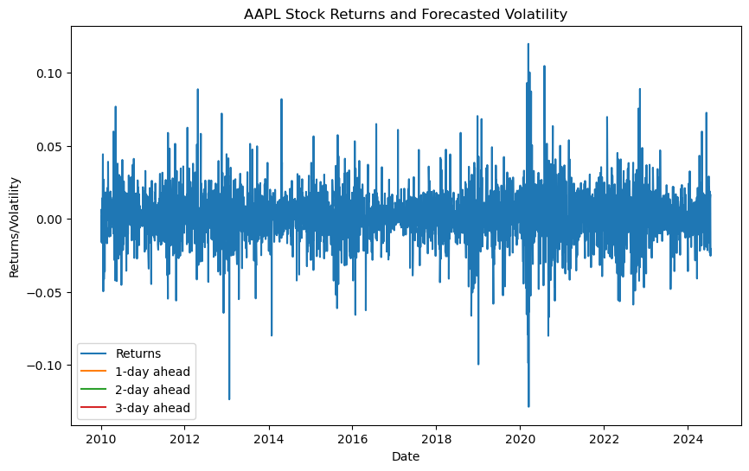

**R**

**# Load required libraries**

library(tidyquant)

library(dplyr)

library(lubridate)

library(tseries)

library(forecast)

library(rugarch)

# Download data from Yahoo Finance

data <- tq_get('AAPL', from = "2010-01-01", to = "2024-07-19")

# Ensure adjusted column is an xts object and calculate returns

data_xts <- xts(data$adjusted, order.by = data$date)

returns <- dailyReturn(data_xts, type = "log")

data <- data %>% mutate(Returns = as.numeric(returns)) %>% na.omit()

library(FinTS)

# Check for ARCH/GARCH effects

arch_test <- ArchTest(data$Returns, lags = 1)

print(arch_test$p.value)

# Fit a GARCH(1,1) model

spec <- ugarchspec(

variance.model = list(model = "sGARCH", garchOrder = c(1, 1)),

mean.model = list(armaOrder = c(0, 0))

)

model <- ugarchfit(spec = spec, data = data$Returns)

# Forecast three-month (90 days) volatility

forecasts <- ugarchforecast(model, n.ahead = 90)

volatility_forecasts <- sigma(forecasts)

# Create a data frame for plotting

data_plot <- data.frame(Date = data$date, Returns = data$Returns)

forecast_dates <- seq.Date(from = as.Date(tail(data$date, 1)), by = "days", length.out = 90)

forecast_data <- data.frame(Date = forecast_dates, Volatility = as.numeric(volatility_forecasts))

# Plot returns and forecasted volatility

plot(data_plot$Date, data_plot$Returns, type = "l", main = "AAPL Stock Returns and Forecasted Volatility", xlab = "Date", ylab = "Returns/Volatility", col = "black", ylim = c(-0.1, 0.1))

lines(forecast_data$Date, forecast_data$Volatility, col = "red")

legend("topright", legend = c("Returns", "Forecasted Volatility"), col = c("black", "red"), lty = 1, cex = 0.8)

<https://github.com/BalaVigneshAravindan/SCMA-632-C51---Assignments/blob/5c0508f06bccebf1570e163e6835ebb2fd928bf5/A6b%20Part%20A..R>

<https://github.com/BalaVigneshAravindan/SCMA-632-C51---Assignments/blob/5c0508f06bccebf1570e163e6835ebb2fd928bf5/A6b%20Part%20A.ipynb>